Name ……………………………………………………………………… Class: …………………………………………………………

Objectives: The students should be able to:
- Describe the composition and molecular structure of glycerol, fatty acids, triglycerides, phospholipids
- Recognize that lipids are formed of fats and oils

Activity 1:
1-Write the chemical formula of glycerol

2-Draw a simple diagram for a triglycerides

3-Describe the structure of triglycerides

4-Draw a simple diagram for phospholipids

5-Describe the structure of phospholipids

6- Write the name of the following drawing
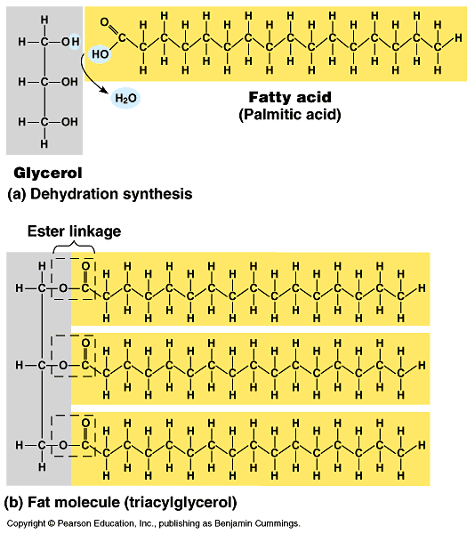

…………………………………………………………………………………………………………………………………………………………………………..

ACTIVIYT 2
1-complete the following statements
a-Lipids include ……………and …………………..
b-At room temperature fats are ………..and ………...
c-Triglycerides consist of one molecule of ………..and three fatty acid molecules
d-Phospholipids are formed of one molecule of ………. , one molecule of ……… and two molecule of ………
e-Examples of lipids are ………… and …………..
II- Choose the correct answer
a-Triglycerides are composed of three fatty acids molecules joined to a molecule of (glycerol-glucose ).
b-At room temperature (fats –oils ) are usually liquids.
c-At room temperature (fats – oils )are usually solids.

HOMEWORK due date next period
a-Lipids include ………..and ………….
b-At room temperature………are solid but……..are liquid and both are lipids
c-Triglycerides consist of one molecule of…………..and three molecules of …………
d-Phospholipids are formed of one molecule of………….,one molecule of………….and two molecules of ……………
2- Write the scientific term for
a-They consist of one molecule of glycerol and three fatty acids molecules ( )
b-They consist of one molecule of glycerol, one molecule of phosphate and two molecules of fatty acids ( )
c-One of the lipids that it is solid at room temperature ( )
d-They are a large and varied group of organic compounds .They include fats and oils ( )
3-Draw a simple diagram for
a-phospholipids
b-A triglyceride

توقيع ولى الأمر

